|  |  |
| --- | --- |
| [KAN-18] [The system publishes a comment with a length of 1 character](https://tmelnychok30.atlassian.net/browse/KAN-18) Created: 15/вер./24  Updated: 15/вер./24 | |
| **Status:** | To Do |
| **Project:** | [Pet-Project AI Guru](https://tmelnychok30.atlassian.net/secure/BrowseProject.jspa?id=10000) |
| **Components:** | None |
| **Affects versions:** | None |
| **Fix versions:** | None |

|  |  |  |  |
| --- | --- | --- | --- |
| **Type:** | Bug | **Priority:** | Medium |
| **Reporter:** | [Tetiana Melnychok](https://tmelnychok30.atlassian.net/secure/ViewProfile.jspa?accountId=712020%3A4e68e605-a434-4948-bfa8-bb53c39de0a3) | **Assignee:** | [Tetiana Melnychok](https://tmelnychok30.atlassian.net/secure/ViewProfile.jspa?accountId=712020%3A4e68e605-a434-4948-bfa8-bb53c39de0a3) |
| **Resolution:** | Unresolved | **Votes:** | 0 |
| **Labels:** | functional | | |
| **Remaining Estimate:** | Not Specified | | |
| **Time Spent:** | Not Specified | | |
| **Original estimate:** | Not Specified | | |

|  |  |
| --- | --- |
| **Attachments:** | image (2).png |
| **Issue links:** | |  |  |  |  | | --- | --- | --- | --- | | **Blocks** | | | | | blocks | [~~KAN-9~~](https://tmelnychok30.atlassian.net/browse/KAN-9) | Testing the field for writing comments | Done | |
| **Rank:** | 0|i0003j: |

|  |  |
| --- | --- |
| **Description** |  |

|  |
| --- |
| **Steps:** 1. Open the article "Renderahouse - потужний інструмент для дизайнерів інтер'єру": <https://aiguru.com.ua/renderahouse-potuzhnyy-instrument-dlya-dyzayneriv-interyeru/>; 2. Scroll down the page with the article; 3. Click on the comment input field; 4. Enter "А" in the comment input field; 5. Fill in the fields "Імя" and "Email"; 6. Click on the "Опублікувати коментар" button;  **Expected result:** The message "Мінімальна довжина тексту - 2 символи" appears.  **Actual result:** Comment published; comment is waiting for confirmation by the website administrator. |

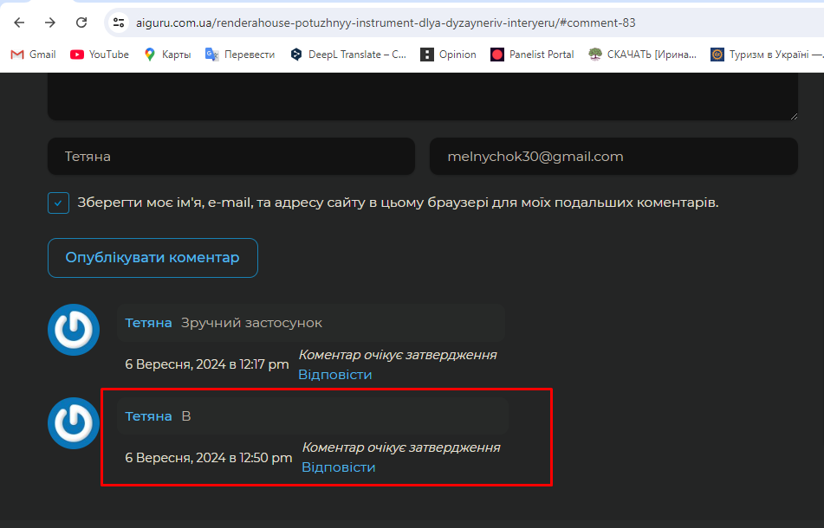

Generated at Wed Sep 18 10:07:07 UTC 2024 by Tetiana Melnychok using Jira 1001.0.0-SNAPSHOT#100266-rev:ad659bfedd37e84df77f3282f1ff9608fe72e5e4.